**EXPERIMENT -2: Container Lifecycle**

**1)docker ps-** This command is used to show the running containers by default.



**2)docker ps -a** - This command is used to show all the containers available either running or stopped.



**3)docker create -** This command creates a new container from the specified image, without starting it.

Here we are making the ubuntu container and naming it “ubucon”

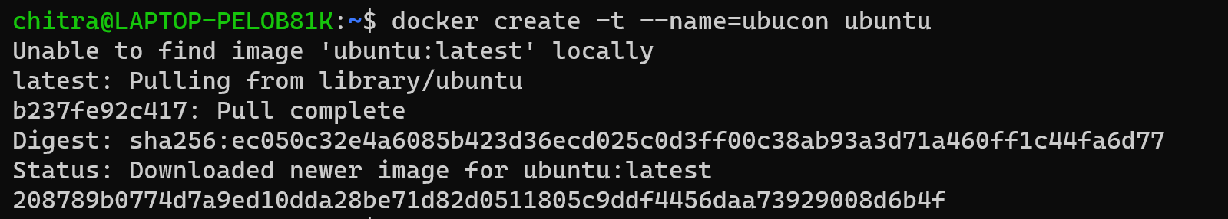

**4)docker start** - This command is used to start the newly created or stopped container.





**5)docker stop** – This command is used to stop the running containers.

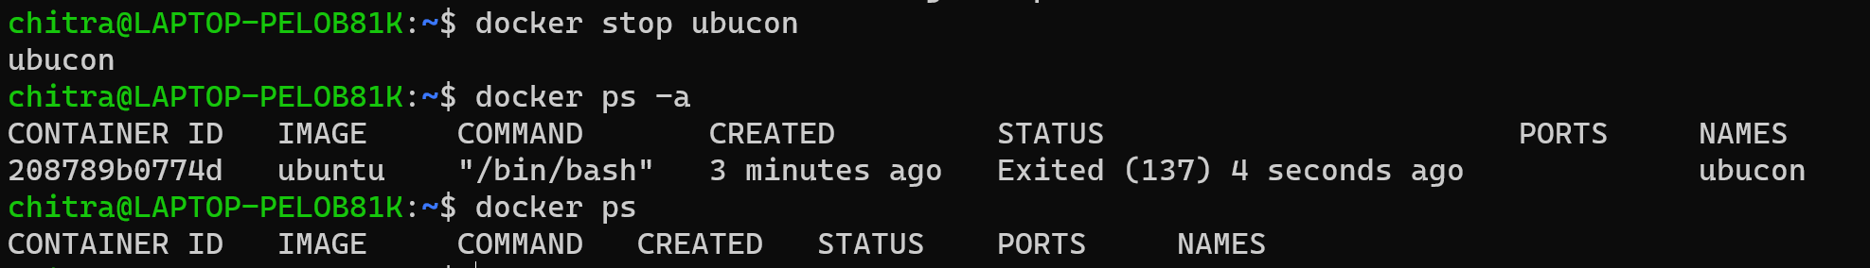

**6)docker kill** – This command kills one or more containers

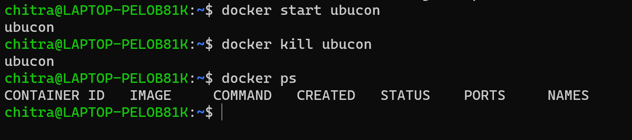

**7)docker restart** - This command restart one or more containers

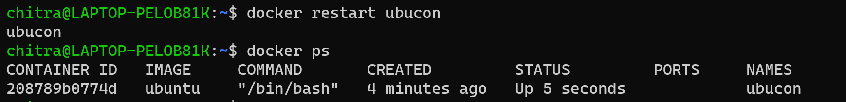

**8)docker pause** - This command pause one or more containers

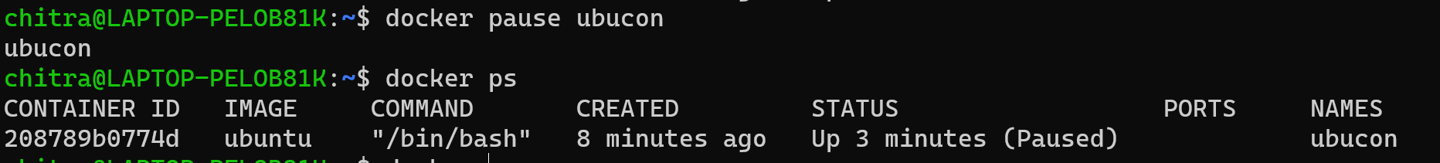

**9)docker unpause** - This command unpause one or more containers

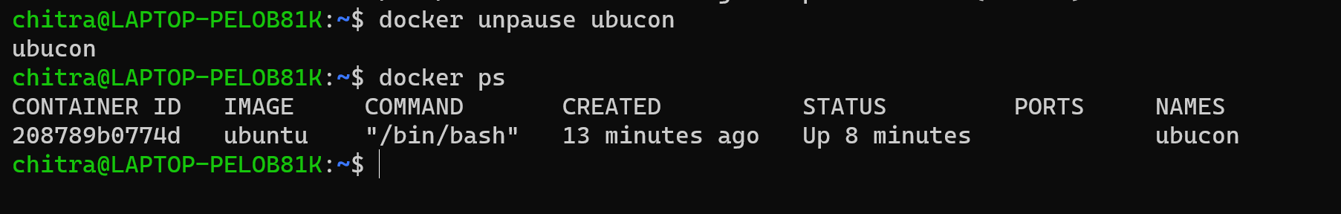

**10)docker rm** – This command is used to remove the containers that are not running.

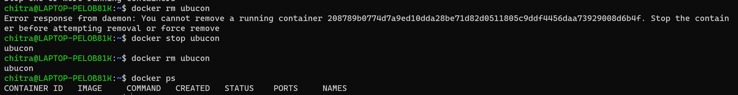

**11)docker run -dt** – This command is used to start the container in the detached mode.

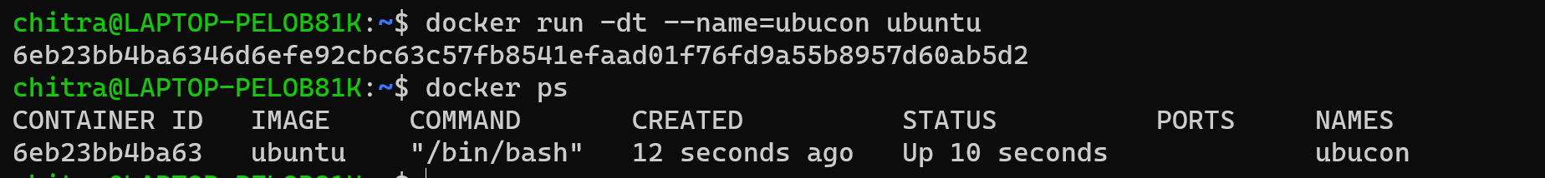

**12)docker run -it** – This command is used to start the container in the interactive mode.

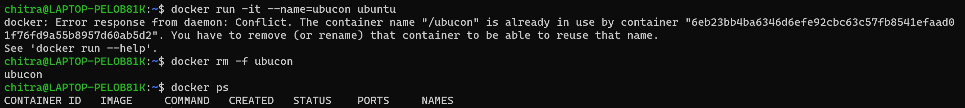

**13)docker run hello-world** – This command is executing a simple “Hello world” program by pulling the hello-world image from the docker hub.

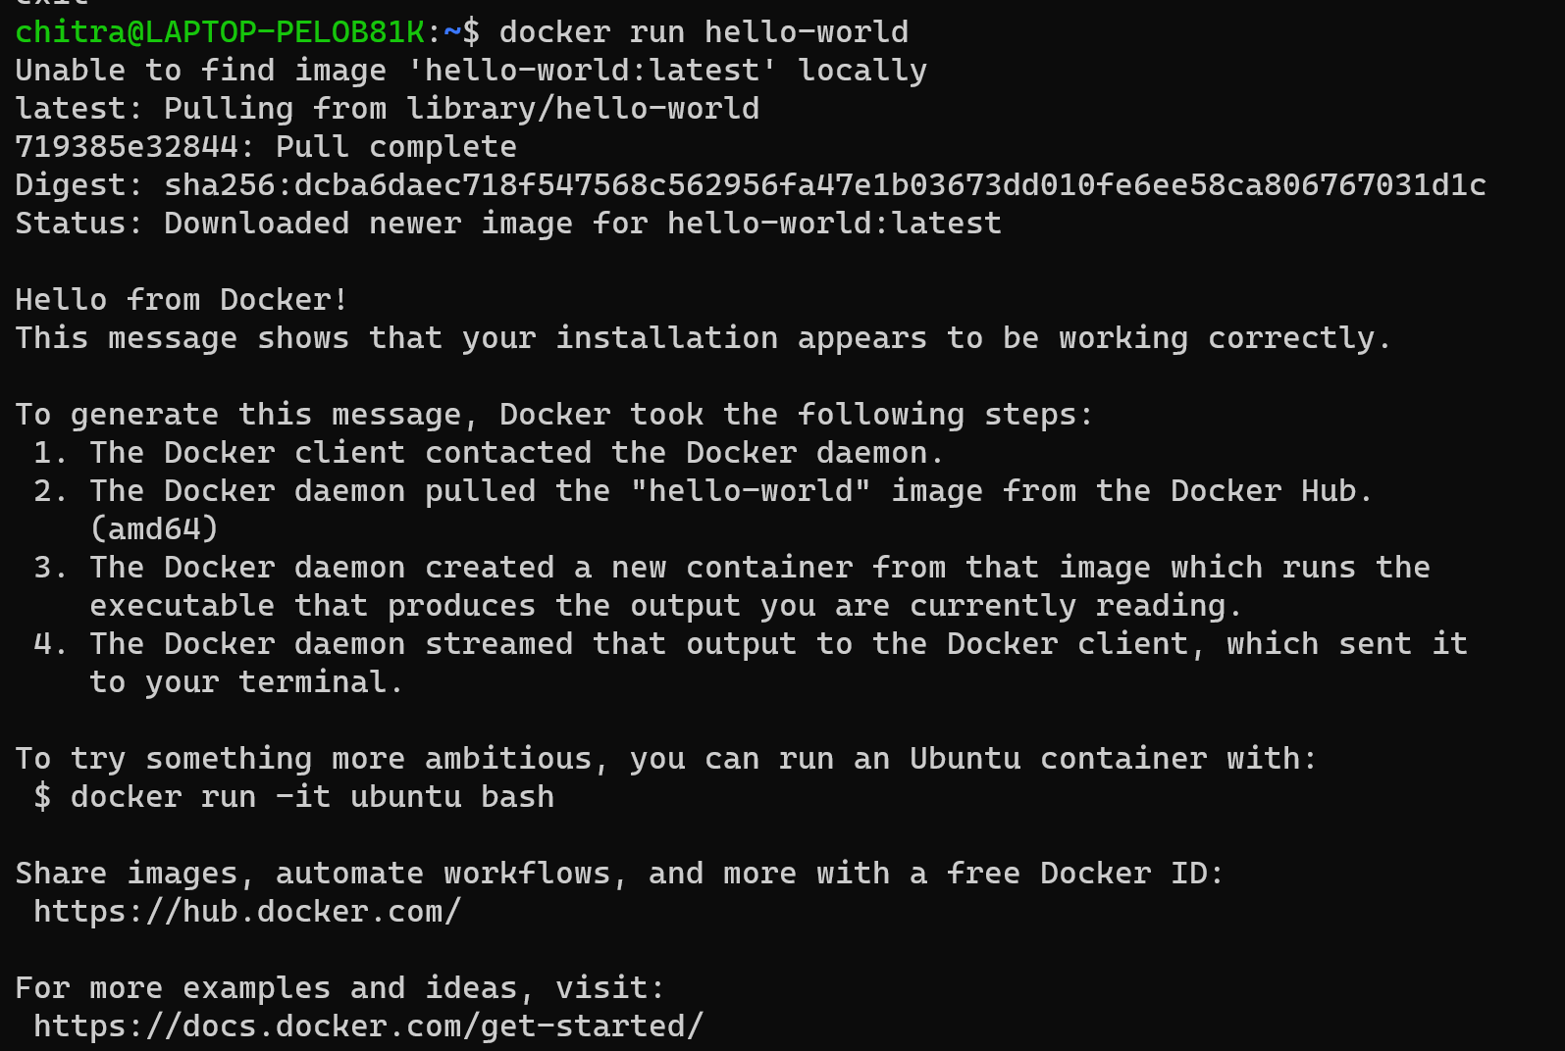

**13)docker run -it –name=ubucon ubuntu:19.04** – This command is creating and running the ubuntu container of version 19.04 in interactive mode.

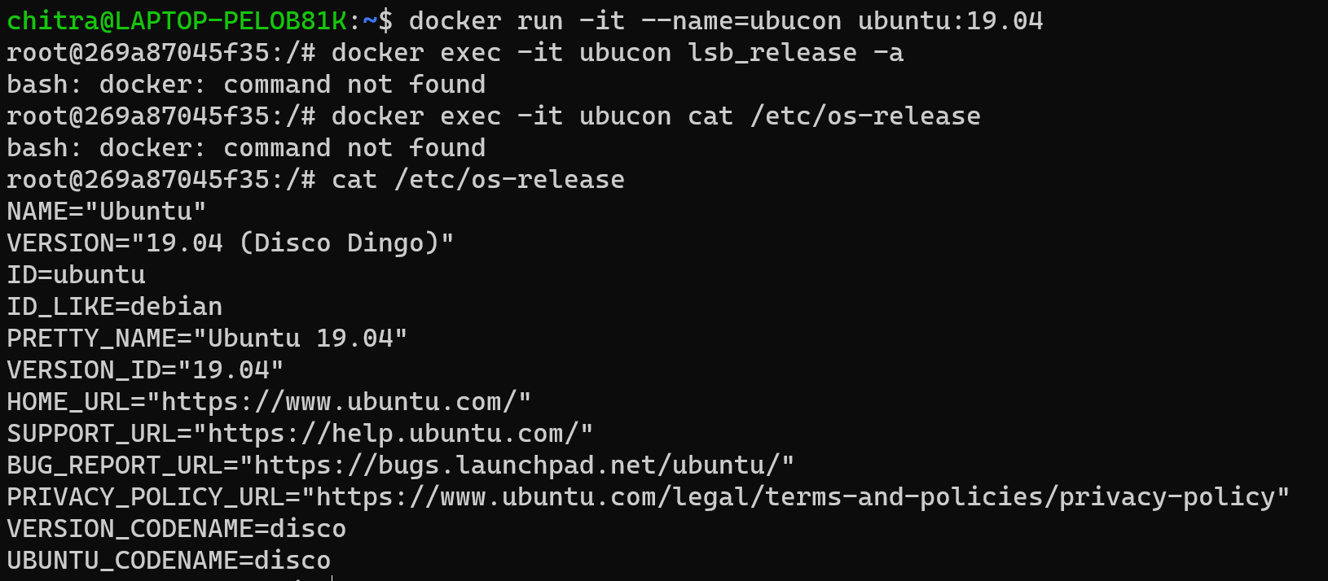

Here, the command used to check the version of Ubuntu inside the shell is

Cat /etc/os-release